Updated January 2021

Brookfield Park Surgery
www.brookfieldparksurgery.co.uk
68 Chester Road London N19 5BZ

A Guide to our Services

Telephone: 020 7263 9633

This practice is within Camden Borough Primary Trust Area
Welcome:

Our practice serves the area within the following borders:
North: Highgate High Street/Fitzroy Park
East: Junction Road / Fortress Road
West: Highgate Road

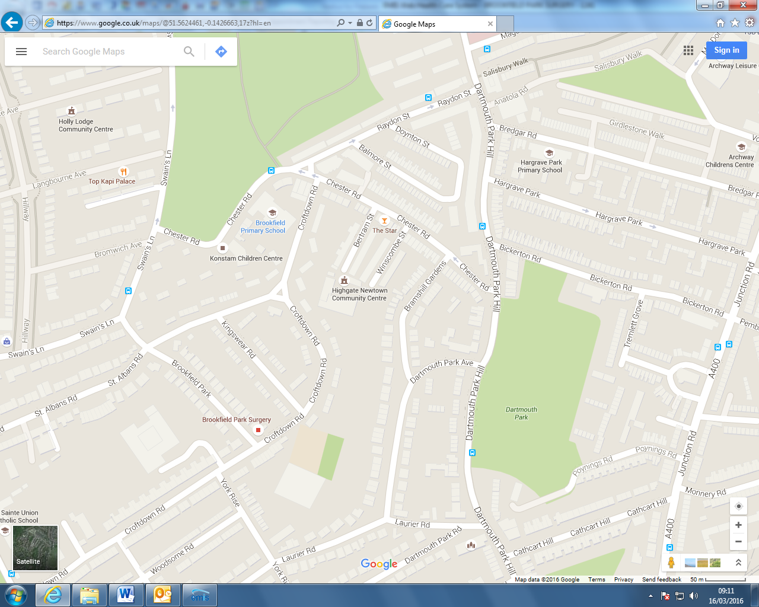
New Surgery

Bus routes that serve this area are: C11
New Surgery
Nearest tube station: Archway Tube Station, Tufnell Park

Registering at the surgery:

Should you wish to register here with us, please come to the surgery and bring your identity proof.

How to register: New patients who permanently reside within the current practice boundary who wish to register should come in to collect a registration pack from reception. New patients will be asked to complete a Registration Form and provide Proof of Identity, and a valid NHS Number. Reception staff will help measure current blood pressure, weight and height. You will need to complete a Registration form and a New Patient Health Questionnaire. You will need to book an appointment with Health Care Assistant.

The practice does not discriminate on the grounds of race, gender, social class, age, religion, sexual orientation or appearance, disability or medical condition.

Details:
Surgery Hours:
Monday 8.00 am to 6.30 pm
Tuesday 7.30 am to 6.30 pm
Wednesday 8.00 am to 6.30 pm
Thursday 7.30 am to 6.30 pm
Friday 7.30 am to 6.30 pm

We offer extended hours on Thursday and Friday from 7:30am to 8:00am for booked appointments only.

Doctors Consultation Hours:
Monday: 08.30 am till 12.30 pm and 3.30 pm till 6.30 pm
Tuesday: 07.30 am till 12.30 pm and 3.30 pm till 6.30 pm
Wednesday: 08.30 am till 12.30 pm and 3.30 pm till 6.30 pm
Thursday: 07.30 am till 12.30 pm
Friday: 07.30 am till 12.30 pm and 3.30 pm till 6.30 pm

Appointments:
If you need to a see a doctor then please contact the surgery by telephone or drop in to make an appointment. If you want to be seen on the same day, phone at 8.00am for a morning appointment or at 1:00 pm for an afternoon appointment. Please note that same day appointments operate on a first come, first served basis. If you would like an appointment with a particular practitioner, please inform the receptionist and we will do our best to accommodate you, but to see a particular doctor, please be aware that you may have to wait longer than 48 hours.

Online Appointments: You can also book appointments online. For further information please contact reception for your access details.

If it is an emergency, please make it clear that you have an urgent problem as an appointment at short notice can be arranged. The reception staff will take your telephone number and a doctor will call you back to discuss your emergency. Following this, the doctor will be able to offer you advice, prescribe suitable medication or offer you an emergency appointment.

Lateness: It is the Practice policy that if you are more than 10 minutes late you may have to re-book an appointment. If your situation is urgent then you may have to wait to see the doctor as an emergency.

Cancellations: If you cannot attend for your booked appointment please ring the surgery to cancel as early as possible, so that your appointment can be offered to another patient.

Telephoning the surgery: The surgery can be contacted by telephone between 8.00 am and 6.30 pm every day except weekends. For care outside those hours please refer to the ‘out-of-hours’ services listed on the back page of this leaflet.

Home visits. These are generally only needed for the housebound who are unable to attend the surgery. If you think you need an urgent visit, please telephone before 10am to discuss your situation with the duty doctor. The decision to provide a home visit will be made on clinical grounds. It is normally perfectly safe for patients, even with an acute illness, to come to the surgery.

Out of Hours. In the case of a genuine medical emergency, which cannot wait until the surgery is next open, please telephone (between the hours of 8:00am to 6:30pm during a normal weekday) Care UK on 0207 388 5800 or (between 6:30pm and 8:00am or at any time on weekends or bank holidays) call 1-1-1. Calls to 111 are free from landlines and mobiles.

Evenings and Weekends. Camden GP Hubs offer appointments to Camden residents or patients registered with a Camden GP.

They are open weekday evenings from 6.30 – 8pm, and weekends from 8am – 8pm.

To book an appointment please call 020 7391 9979 or visit camdengphubs.co.uk

Repeat Prescriptions: Please allow two working days for repeat medication requests to be processed. Please order repeat medication in writing preferably using the list attached to your prescription. If you haven’t been seen for some time you may be asked to see the doctor for a review.

Online Repeat Prescriptions: You can also request online repeat prescriptions. For further information please contact reception for your access details.

Disabled access: Wheelchairs can enter the practice.

Staff and Services:

The Staff:

Clinicians:

Dr. Meena Anand, MBBS, MRCGP, DRCOG, DFSRH
Dr. Asma Akther MRCGP, DOHNS
Dr. Henry Goodfellow,

Claudette Reid Practice Nurse

Administrative:

Sarah Gallagher Practice Manager

Ghada Ghalayini Receptionist & Administrator
Charlotte Marden Receptionist & Administrator
Kalpna Lakhani Receptionist & Administrator
Dawne Glean Receptionist & Administrator

Services:

In addition to general medical services the practice also provides the following services:

- NHS Health Check Clinic
- New Patient Health Check Clinic
- Sexual Health Clinic
- Cervical Screening Clinic
- Antenatal & Post Natal Clinic
- Women’s Health Clinic
- Family Planning Clinic
- Long Term Condition Management Clinic
- Smoking Cessation Clinic
- Baby Clinic
- Bowel Screening

CLINICS

Baby clinic: 8 week baby checks and all immunisations done at the surgery except BCG. Please book 8 weeks with Doctor and Nurse well in advance as it needs double appointment.
Contraception and family planning: Please come and see the doctor to discuss the various options available. Follow up appointments can be with the nurse or one of the doctors. Coil and Implant fitting is done by Dr Anand
Travel advice: Our nurse offers advice about travel vaccinations. Please can into surgery and collect a Travel Immunisation Information Form.
Antenatal/Postnatal care: We offer shared antenatal care with the Royal Free Hospital, the Whittington Hospital and University College Hospital. If you are pregnant please make an appointment to see one of the doctors who can discuss the options with you. You will be offered a post-natal check six weeks after delivery. Patients are able to self-refer to Maternity Services without seeing a GP.
Smoking cessation: Please book an appointment with reception for the Smoking Advice Clinic held in surgery.
Counsellor. The practice refers to the counsellors.
Confidentiality. You can be sure that anything you discuss with any member of this practice – family doctor, nurse or receptionist – will remain confidential. However, for the effective functioning of a multi-disciplinary team it is sometimes necessary for your medical information to be shared between members of the practice team. Everyone working in the NHS has a legal duty to maintain the highest level of confidentiality regarding patient information.
Data Protection. We are registered with the Data Protection Agency and are bound by the rules governing the collection and storage of personal data. Patients are entitled to see their medical records and to have copies for a small fee. We recommend that if you wish to see your records a time is arranged to do this with your registered GP as there may be medical terminology that requires explanation.
Responsibilities: We aim to provide excellent healthcare as detailed in this leaflet. This is only possible if patients co-operate with the practice. In particular, we expect patients to provide the necessary information and co-operate with procedures to allow us to meet public health requirements.
Sharing Information within NHS: Patient will be provided with opt in/opt out form Summary Care Record, Care.data and Camden Integrated Digital Record. Forms are available at reception desk.
Camden Walk-in Centre is located at Soho NHS Walk-In Centre,
1 Frith Street, Soho, W1D 3HZ, Weekdays, 8am-8pm, Weekends and bank holidays, 10am -8pm, Tel: 020 7534 6500.

Details of primary medical services in the area may be obtained by contacting Patient Services: North Central London Clinical Commissioning Group, Euston Tower,
286 Euston Road, London, NW1 3DP

Tel: 0207 688 1700

Patient Participation Group is the group of Brookfield Park Surgery patients. Meetings are held six monthly. Please contact reception for further information or visit the practice website. You can fill the form and leave your contact details, if you wish to be a member of the PPG.

Complaints

The procedure is intended to provide an explanation, an apology, if necessary, an indication of action to be taken by the practice to resolve the problem, if that is possible and to ensure that it does not recur. The procedure is not intended to apportion blame, to consider the possibility of negligence, or to provide compensation.

If you have a concern about the care or service you have received, please write to the Practice Manager.

Please hand in your letter at the Reception Desk or post it to us.

Once we have received your complaint, we will send you an acknowledgement within forty-eight hours, along with an invitation to come in and discuss the matter with us within three working days, should you so wish and an internal inquiry will be launched.

We will aim to respond formally, in writing, to your concerns within ten days and will keep you informed of progress throughout the process.

Most complaints can be resolved to the satisfaction of both parties internally, at practice level. However, sometimes this procedure may not prove sufficient and so, if, once we have forwarded a formal response to your complaint, you remain dissatisfied, you can refer the matter to:

NHS Complaints Advocacy
Web: www.nhscomplaintsadvicacy.org
Tel: 0300 330 5454
NHS England
Complaints Department
15 Marylebone Road, London NW1 5JD

If you wish we can get independent conciliator to discuss things further.

If you remain unhappy after everything has been done to try to resolve your concern or complaint you have the right to approach the Health Services Ombudsman.

The Health Service Ombudsman
Tel: 0345 015 4033
Email: phso.enquiries@ombudsman.org.uk
Write: Millbank Tower, Millbank, London SW1P 4QP

The practice undertakes an annual review of all complaints to address any changes in practice or systems that can be implemented to avoid further problems.
Patient Charter

All our patients are treated with courtesy and respect for their privacy and personal beliefs.

If you have not attended the practice in the last three years and you live within the practice boundary (see map) you will have the right to have a consultation. If you are a new patient, you will be offered a simple health check. If you are aged over 75, you will have a Named GP and will be offered a routine health check every year.

If you have a problem, you will be able to consult a doctor the same day, though this may have to be by phone. Please remember when you call, that it is up to the doctor to decide what action is required.

You can expect to be referred to a specialist if necessary.

You may choose whether or not to take part in any research or student training.

The practice is registered with the Data Protection Agency and is bound by the rules governing the collection and storage of personal data. Your personal data will only be seen by professionals at the practice involved in providing your care. However, this data can be made available to healthcare providers at other locations with your consent. Occasionally anonymised health information is sent to Camden CCG to support the monitoring of quality of care and public health analysis.

Under the Data Protection Act 1998, you have a right of access to your health records. If you wish to be given a copy of your records a small fee will be charged for this service to cover the cost to the practice. If you would like to apply for access to your records, please do so in writing.

If you a friend or relative is looking after you during an illness and you want them kept informed about your treatment, we will ensure that this is done. Please make sure that the doctor knows who that person is and make it clear that permission is granted.

Comments and suggestions are welcomed by the Brookfield Park Surgery. A Comments and Suggestions Book is available at the Reception desk for patients to use, if they wish or they can email us on brookfieldpark@nhs.net . Alternatively patient can review and rate surgery on NHS Choices www.nhs.uk

Alternatively, if you prefer your comments or suggestions not to be seen by other patients, you may submit written suggestions to our reception desk and these will be dealt with in the strictest confidence.

We ask of you:

Please treat the team at the practice with the same courtesy and consideration that you expect to receive yourself. Violence and abuse will not be tolerated either to staff or other patients and can result in you being removed from our patient list or the police being informed.

Please only call a doctor out at night in an emergency. You can do this via the Out of Hours Service, Care UK. Your request will be treated sympathetically but bear in mind that the doctor will most likely have to work the next day and may have other patients to see that night. Remember, it is up to the doctor to decide whether or not an emergency exists.

Please let us know if you change your name (by getting married, for example) or if you change address or telephone number.

Please keep your medical card safe.

Finally, remember that you have a part to play in your care. You can help the doctor by telling him or her exactly how you feel and then listening to what the doctor says. If, at any time, you do not understand what the doctor is telling you then please do say so.

